Massage Therapists
Personal Trainers
Robin Godlewski (Patch, PZ, Kelley)
Aerobics & Fitness Association of America (AFAA)
- Certified Personal Trainer
Email: buffdawgs@hotmail.com
Phone: 071167210895

Tiana B. Hertenstein, CSCS (RB)
National Strength & Conditioning Association (NSCA)
- Certified Strength & Conditioning Specialist
- Certified Coach USA Weightlifting Level 1 Sports Performance
Email: perrytb@gmail.com
Phone: 0152-563-31219

Payton Fearnside (Patch, PZ, Kelley)
International Sport Sciences Association (ISSA)
- Certified Personal Trainer
Email: Paytonfearnsidefitness@gmail.com
Phone: 015232753866

Tommie Edwards (Patch, PZ, Kelley, RB)
International Sport Sciences Association (ISSA)
- Certified Personal Trainer,
- Certified Master Fitness Trainer
Email: edfitnesstraining@gmail.com
Phone: 015110475003

Stephanie Jones (Patch, PZ, Kelley, RB)
National Academy Sports Medicine (NASM)
- Certified Personal Trainer,
Email: stephanieveronicajones@gmail.com
Phone:

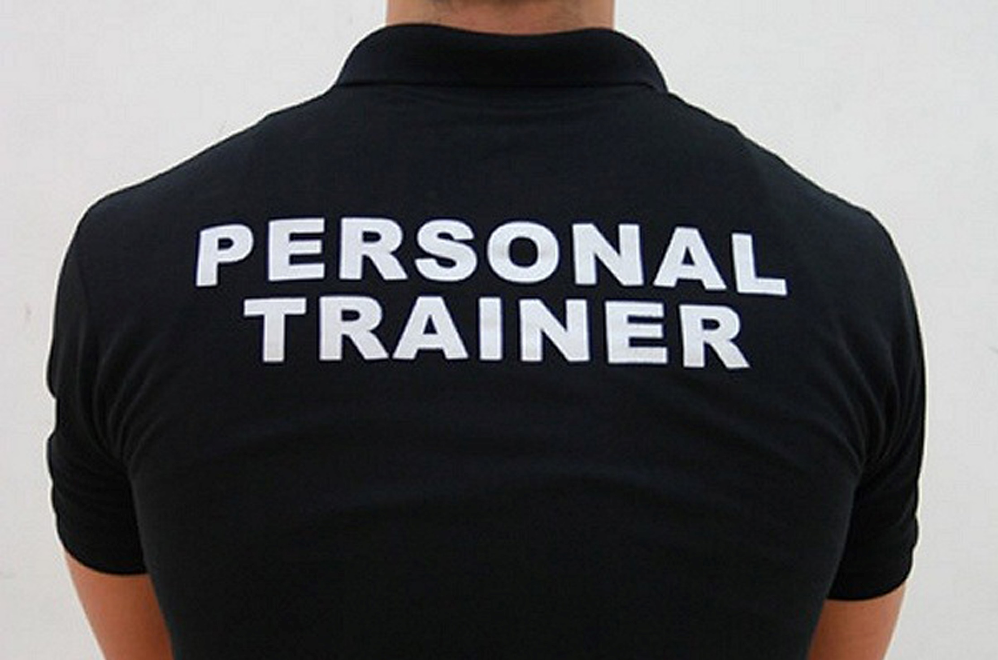

Personal Training Fees
Hourly
One-hour Session $40
One-hour Partner Training* $60

Multiple Session Packages
4 One-hour Individual $145
4 One-hour Partner Training* $220
8 One-hour Individual $290
8 One-hour Partner Training* $430
12 One-hour Individual $430
12 One-hour Partner Training* $650

*Partners must have similar fitness goals and agree to train together for all sessions.

Gabrielle Brandt (Patch)
Pregnancy Massage:
$90 for 90 min., $70 for 60 min., $40 for 30 min.
Deep Tissue/Sports Massage:
$90 for 90 min., $70 for 60 min., $40 for 30 min.
Aurum Manus Massage, Ayurvedic Massage:
$70 for 60 min.
Reflexology:
$45 for 45 min.
phone: 0711-745-7602
e-mail: Brandt415@googlemail.com

Dhiana Grabert (Patch, Panzer, Kelley)
Deep Tissue:
$95 for 90 min., $70 for 60 min., $45 for 30 min.
Swedish:
$95 for 90 min., $70 for 60 min., $40 for 30 min.
Full-body Hot Stone:
$110 for 90 min.
phone number: 0152-0478-9677
e-mail: dhianagrabert@yahoo.com

Chris Robson (Kelley)
Integrative Massage:
(Combines: Deep tissue, Myofascial Release,
and Swedish Work. Longer sessions include
aromatherapy and hot towels or stones)
$95 for 90 min., $85 for 80 min.,
$75 for 60 min.
Swedish Massage:
$70 for 60 min., $40 for 30 min.
Reiki:
$65 for 60 min
Lymphatic Drainage: $80
Full-body Hot Stone: $110
phone: 0160 - 9812 - 2862
e-mail: kvc474@yahoo.com

Melanie Zoller (RB)
Swedish, Deep Tissue, Sports Massage, Reflexo

