Brandy Thomas
Certified Yoga Instructor
Kelley/Robinson Fitness Centers: Yoga
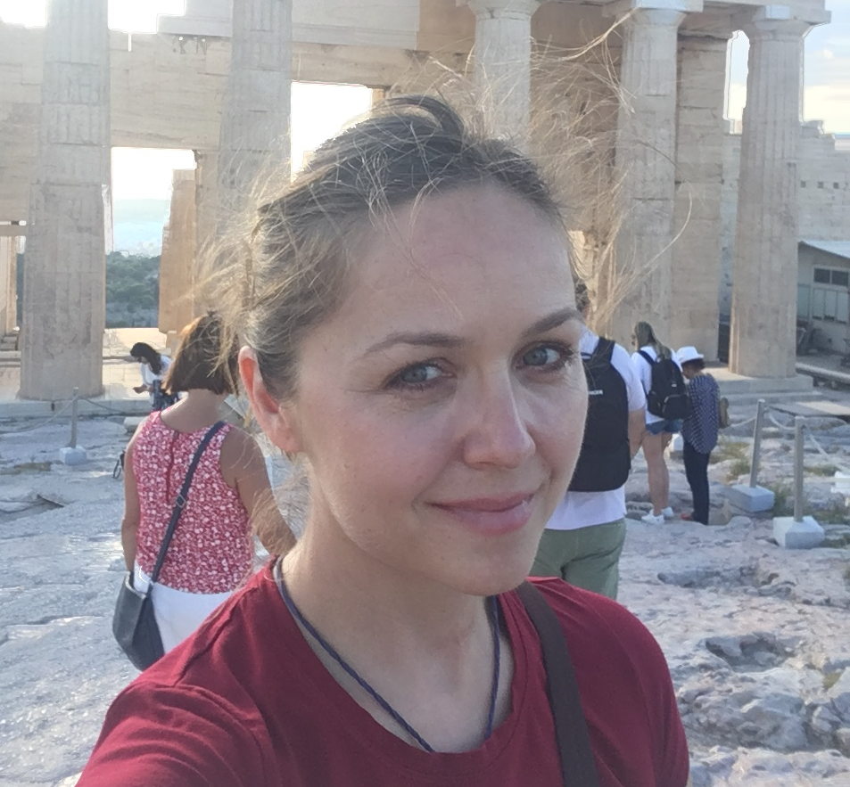
Philosophy
As a deployable Marine, I have always sought physical training that I can take with me anywhere and anytime. It was not until I stumbled into Synergy Yoga in San Diego, CA, that I found a form of physical fitness that not only centers you, but is also extremely safe, meets you where you are in your path to health and fitness, and proves extremely healing on all levels. I trained for two years with a studio in Encinitas, CA, and obtained my 500-hour certification in 2006. Since then, I have taught at MCAS Miramar, up in Point Arena, CA, while deployed to the country of Bahrain, and at MCB Quantico, VA. I have taught all levels, from patients who were coming back from injuries and cancer to Special Forces personnel. I recently taught my fellow climbers on our way to the top of Mt. Kilimanjaro! My mantra: “You are perfect just as you are.” This style of yoga improves strength, balance, and flexibility. Yoga is not a competition. One of my favorite comments from a former student: “It doesn’t hurt anymore when I get out of bed in the morning.” I have myself seen the amazing effects of this practice when coming back from a severe knee injury nearly ten years ago. Your strength is in your breath.
Education
United States Naval Academy, B.S.
Naval Postgraduate School, M.S.
Kelley School of Business, Indiana University, M.B.A.
Marine Corps University, M. Operational Studies
Current Certifications
Certified Yoga Instructor, 500-hr
CPR/First Aid/AED

